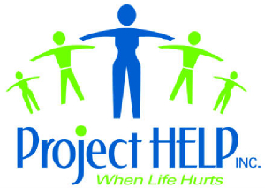
Project HELP, Inc. Crisis & Sexual Assault Center
3123 Terrace Avenue
Naples, Florida 34104
Office: (239)649-1404 FAX: (239)649-5520
HOTLINE: 262-7227
www.ProjectHelpNaples.org

January 2011
Board of Directors
Mark Koestner
President
Wachovia Finacial

Ken Becker
Vice President
Collier County Sheriff’s Office

Phil McGuire
Treasurer

Jacques Groenteman
Secretary
J.R. Wood Realty

Francine Cavaseno
Island Country Club

Helen Heers

Melody Kappauf
Island Country Club

Advisory Board
Senator Burt Saunders
The Honorable Cynthia Ellis
Dr. Marta Coburn
Michael Geraghty, Ph.D.
Nancy Lascheid
Ricardo Rivas, Ph.D.

Medical Director
J. C. Coughlan

Project Help Team
Kelly English
Shaina Hicks
Hernan Pinilla
Julie Rego
Melissa Rounds
Eileen Streight
Eileen Wesley

Executive Director
Michelle English

Dear Friend of Project HELP Crisis Center:

Thank you for your support in helping us this year on Project HELP’s 15th Annual “Chocolate Extravaganza” which will be held on Saturday, February 12, 2011 at the Von Liebig Art Gallery in Downtown Naples. The Chocolate Extravaganza is our signature fundraising event, with your generous donation we are hoping to raise funds which are desperately needed for us to continue our mission of helping those in crisis in our community. Our theme this year is The ART of Giving and “Giving Back”. We hope you are able to join us in “Giving Back” this year.

Your donation of an item or service for either our live or silent auction will help to produce a most memorable event enabling us to raise money to help our community. It is our sincere hope that you will be able to participate by offering an auction item or service that will bring a spectacular donation. We are seeking items that will draw very competitive bids and excitement from the audience. Your donation will not only assist in creating a wonderful event, but also will help us continue our mission in the community. Your donation will go towards helping victims become survivors.

You will be recognized in the Chocolate Extravaganza program, including all print and electronic media acknowledgements of the Chocolate Extravaganza. We have included sponsorship availability information with this letter for your consideration.

Project HELP Crisis & Sexual Assault Center serves victims of crimes throughout Collier County including victims of sexual violence, rape, sudden death and suicide. When life hurts… we provide free professional and compassionate advocacy, counseling and support groups for people from 4 to 94 years old. In addition, we have a 24-hour Crisis Hotline and Referral, which is manned by volunteers and the Project HELP Crisis Center staff. Through your donation, you become a part of the healing process for the traumatized survivors who Project HELP works with every day.

Your donation is tax deductible as we are a 501©(3) non-profit organization. We are asking you to please consider Project Help Inc. in your charitable giving in order to “give back” to the community so that you too, will be helping our most traumatized family members, friends, and neighbors. If you have any questions, please do not hesitate to contact us. We are enclosing an excerpt from our latest newsletter so you can see the astounding numbers from 2010.

Thank you in advance for your consideration of our request. Your contribution will make this event a sweet success!

Forever Chocolate,

Project HELP Inc
Tax Identification: 59-2655969

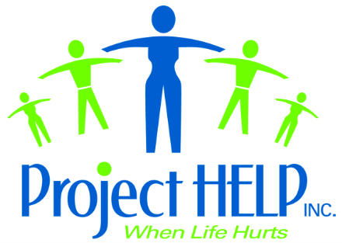

15th Annual Chocolate Extravaganza
Auction Donation

Company: __________________________________ Date: __________

Address: _______________________________________

_______________________________________

Contact: _______________________________________

Phone: _________________________ Fax: ____________________

DONATION-Product /Service Description: __________________________________

_____________________________________________________________________

_____________________________________________________________________

Value: $______________

Please fax this form to Project HELP, Inc. by January 31, 2011.
239-649-5520 fax 239-649-1404 office

3123 Terrace Avenue, Naples, FL 34104

*************************************************************

❑ Sorry, we cannot donate a product or service this year.

❑ Please accept our donation: $__________________________________

Project HELP, Inc. is a 501C(3) non-profit organization and as such, all donations are tax deductible to the extent allowed by law.
For your records, our tax identification number is: 59-2655969. Please note no goods or services are received in exchange for your contribution.

Levels of Sponsorship Support
Project HELP Inc.’s 15th Annual CHOCOLATE EXTRAVAGANZA
February 12, 2011
*We can only guarantee names printed on items printed after receipt of sponsorship. Early submission will get the most exposure*

Event Underwriters $10,000.00
2 Tables for 20 guests
Table centrally located
Logo and brief company description on Website and Social Media Outlets
Logo displayed in all newsletters for 2011
Corporate or patron name listed in program and on all event signage.
Recognition in the newsletter, event invitation, media releases and event advertising
Other benefits tailored to meet sponsor needs – including product placement at event, etc.

Event Sponsor: $5000.00
2 Tables for 20 guests
Table centrally located
Corporate or patron name listed in program and on all event signage.
Recognition in the newsletter, event invitation, media releases and event advertising
Other benefits tailored to meet sponsor needs – including product placement at event, etc.

Godiva Sponsor: $3000.00
1 Table for 10 Guests
Table centrally located.
Corporate or patron name in program, and on all event signage
Product placement at event
Inclusion in all advertising and publicity for the event and newsletter

Ghirardelli Sponsor: $1000.00
Reservations for 5
Table located in good area.
Corporate or patron name listed in program and all event signage.
Inclusion in all marketing materials, advertising, and newsletter

Lindt Sponsor: $ 500.00
Reservations for 2
Corporate or patron name listed in program, and event signage.
Inclusion in all marketing materials, advertising and newsletter

Hershey Sponsor: $ 250.00
Reservations for 1
Corporate or patron name listed in program and event signage
Inclusion in all marketing materials, advertising and newsletter

Event Underwriters: All underwriters will be listed in the program and recognized in all printed materials, including newsletter and event signage. Underwriter benefits will be determined based on the value of the expense underwritten.
Equipment (tables, chairs, linens etc) - $2,200.00
Food (Hors D’oeuvres) - $2,300.00
Beverage (Wine, Champagne, Water) - $2,500.00
Invitations & Program - $2,000.00
Event Space Rental - $1,000.00

Auction Donor: The committee for the 15th Annual Chocolate Extravaganza gratefully accepts items (goods, services, trips, dinners, etc.) for the silent auctions. Donor benefits will be determined based on the monetary value of the item donated.

Project HELP, Inc. is a 501C(3) non-profit organization and as such, all donations are tax deductible to the extent allowed by law. For your records, our tax identification number is: 59-2655969. Please note no goods or services are received in exchange for your contribution.

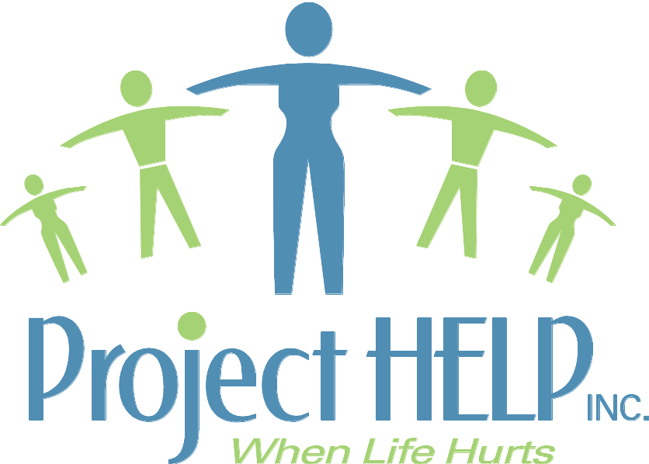

Everyday, bad things happen to good people. Everyday, members of our community are affected by violent crime, rape, homicide, suicide, or the sudden death of a loved one. These VICTIMS and SURVIVORS in our community need immediate and continuing help and guidance. Project Help is here and has been here for 25 years doing just that: Responding immediately and being there through the completion of each victim and survivor’s healing journey. Today we are writing to you for a donation so that we may keep our services to this community going. We are the only crisis and sexual assault center in Collier County. We are the only ones offering free services to Victims and Survivors.

For a quarter century, Project HELP, Inc., the only state-certified Sexual Assault Center in Collier County, has been here for the Naples community. We also operate the 24-hour crisis hotline that provides immediate crisis intervention, information, and referral.

The Crisis Hotline guarantees that the calls of the scared, grieving, battered and bruised are answered by a compassionate and well-trained advocate every time the phone rings. In 2009 we received 1,305 phone calls. In 2010 to date we have already received 1,896 phone calls and we have 1 month to go. Times are getting harder and crime and crisis are on the rise.

In 2009, Project Help employees advocated for and counseled 159 new victims and 54 secondary victims of sexual assault, ensuring their rights were upheld and they received immediate crisis intervention counseling throughout their healing journey. In addition to these new victims, Project Help assisted 421 on-going sexual assault victims and 93 secondary victims throughout the 2009 year. Close to 3000 services were given to these victims/survivors in 2009.

In 2009, Project Help worked with over 2000 victims of crime. These are individuals in our community who had been robbed, battered, abused, victims of elder abuse, physically assaulted, survived a hit and run, felt the trauma of home invasions, or had family members who were murdered. These numbers also include over 80 cases of child physical abuse and child sexual abuse.

Crime and Rape do happen in our neighborhood. We know we don’t like to think about it and we know it certainly doesn’t hit the headlines, but Project Help is here for these victims.

A 16 year old girl on vacation with her father who met some “friends” at the hotel where they were staying. One of these new “friends” invited her to a game of tennis around 9pm. This 16 year old girl was then raped. She was here for what was supposed to be a fun-filled vacation of fishing, swimming, boating, and tanning. Instead she was violated in one of the worse possible ways. She then had to tell her father, who quickly called law enforcement, who then called Project Help. Project Help immediately responded, explaining to this 16 year old victim the importance and process of having a forensic exam, her rights as a victim, and the immediate necessary crisis intervention. Her father, a secondary victim, required crisis intervention as well. A Project Help advocate promptly connected with him and explained the criminal process, as well as some normal behaviors and reactions he could expect from himself and from his daughter. Within about a 3-hour time period, (starting with the call from Law Enforcement to the time the father and daughter left the center) this 16 year old victim was given a forensic exam to collect evidence of the perpetrator, provided with crisis intervention, and was given hotline and rape crisis center information for the area where she lived. Not a vacation anyone would want.
A 34 year-old professional woman met some friends for a drink on a Friday evening after work. As the evening went on this woman started to feel a little blurry. Knowing that she had only had 2 drinks, she approached one of the friends to say she wasn’t feeling well and was going to go home. The friend offered to give her a ride home. When the 34 year-old victim awoke the next morning she could not remember anything after approaching her friend. She didn’t know how she got home or why she was having horrible pains all over her body. The victim went to take a shower only to notice severe bruising all over her body. She phoned our 24-hour hotline and was immediately connected with a Sexual Assault Responder who went over several options with the victim. The victim chose to report the incident and receive a forensic exam.
A husband and wife in their mid 70’s called the Hotline one evening as they had just received a phone call that their 45 year-old son had just committed suicide. The son was experiencing a bad spell with the drop in the economy and had decided to kill himself. The parents didn’t have anyone to talk to. Project Help immediately scheduled appointments for the couple to meet with a grief counselor and after a few sessions invited them to join a grief group. The feeling of loss after a loved one dies never goes away, but we work very hard to help individuals through the process as long as we are needed.

Every week our counselors provide more than 350 hours of direct services to survivors of sexual assault and crime. All of our services have been and will always remain free to those who need us…your friends, your family, your co-workers, your neighbor, your bagger at the grocery store. When a victim or a victim’s family or friend needs help, Project HELP is here.

We are writing to you with a plea of HELP ourselves. This year alone funding has been cut $89,000, donations are down, and crime and crises are at a new high. Without your support of what we do for those in need in the community, our services will have to be taken away at a time when they are needed most. We need your donation now to be able to keep helping those who need us most – victims of crime and loss.

Your donation helps each victim become a survivor. Whether teaching coping skills for every-day crisis, or facing life after a rape, a homicide or a suicide, each victim becomes a survivor. Your donation will pay for a victim’s ability to continue on, a child who will learn not to be afraid, a woman who will be able to return to work, a mom and dad who will learn to live with the loss of a child. Your donation matters! Your donation today, matters to all in our community.

We thank you for supporting us as your donation helps us maintain the quality programs we have established for this community. Your donation can help us to continue Honoring, Empowering, and Listening to People in our community in crisis.

Sincerely,
Michelle English
Executive Director

We also need HELP...

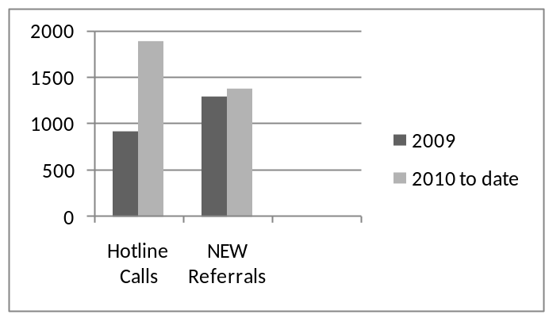
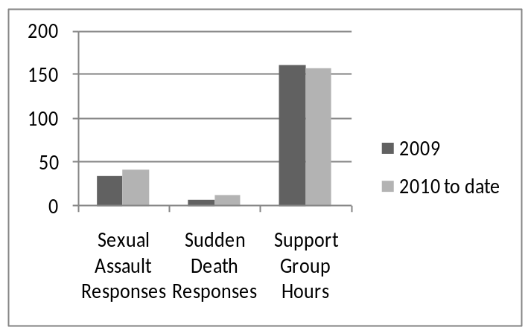
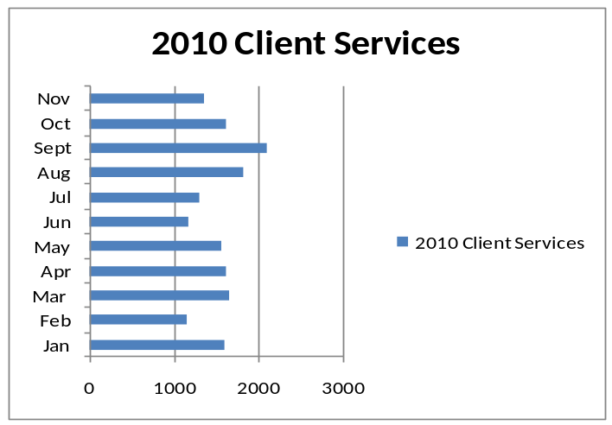
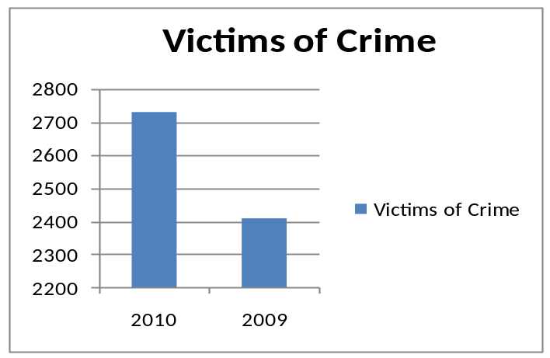
Responses & Groups
Hotline Calls & Referrals
your help...helps us HELP ALL

